Early identification of Glacial Lakes Outburst Floods (GLOFs) using deep learning algorithms with different backbones and loss functions

Sundeep Raj
Department of CSE(AIML)
KIET Group of Institutions
Ghaziabad, India
sundeepraj1@gmail.com
Shakti Kumar
Department of CSE(AI)
KIET Group of Institutions
Ghaziabad, India
shakti.2226cseai1067@kiet.edu
Shikhar Singh
Department of CSE(AI)
KIET Group of Institutions
Ghaziabad, India
shikhar.2226cseai117@kiet.edu
.
Vilakshan Saini
Department of CSE(AI)
KIET Group of Institutions
Ghaziabad, India
vilakshan.2226cseai1@kiet.edu

Abstract— In Himalayan region, the Glacial lake outburst flood(GLOF) is a major concern, by which thousands of glacial lakes created due to glacier melt in the various states of India like Uttarakhand, Himachal Pradesh, Sikkim, Jammu and Kashmir, and Arunachal Pradesh, as well as Union Territories like Ladakh with high Himalayas and other high snow mountain ranges. They are especially vulnerable, highlighting the need for robust monitoring and mitigation strategies. This paper focuses on using Deep Learning (DL) models for detecting and segmenting glacial lakes to mitigate GLOF risks. Using the Glacial Lakes Detection Dataset from High-Mountain Asia, covering 2080.12 km², we selected 1,200 cloud-free true-color images with ground truth masks. Our study evaluates DL models like DeepLabV3+ and U-Net for lake segmentation and classification. Experimental results demonstrated model proficiency, with DeepLabV3+ (ResNet50 backbone and Dice loss function) achieving the highest IoU score of 74.69% with 90%accuracy along with 98% with U-Net + EfficientNetB0. Our study highlights the capacity of DL-based systems for enhanced GLOF monitoring and early warning.
Keywords—Glacial Lake outburst floods (GLOF), Geomorphic, Convolutional Neural Networks (CNN), DL models (Deep learning models), climate change, satellite imagery, deep neural network, segmentation, classification.

Introduction
Glacial lakes play a vital role in supplying freshwater for irrigation, domestic consumption, and industrial applications to both local and downstream communities. However, these lakes are increasingly vulnerable to the impacts of global warming. In many snow mountains regions, the rising temperatures have accelerated glaciers to melt, causing recurrent damage to houses, farmland, orchards, and forest areas. GLOFs have thus become one of the most visible indicators of climate change in mountainous regions worldwide [1]. These events, characterized by their high intensity and rare occurrence, significantly affect human settlements and the regional geology and geography.
Fine-grained information extraction along with Accurate image segmentation are now possible due to various recent advancements in deep learning. In this study, U-Net and DeepLabV3+ architectures are employed to segment small-scale glacial lakes from satellite imagery, enabling accurate pixel-level detection and mapping.
GLOFs pose substantial risks to communities and infrastructure, necessitating their effective detection and monitoring. Previous researches have utilized DL techniques, including Convolutional Neural Networks (CNN) and automated monitoring systems, to monitor glacial lake formations and enhance the accuracy and efficiency of GLOFs detection. Recent advancements in deep learning–based semantic segmentation and multispectral remote sensing have significantly enhanced the capacity to detect and monitor Glacial Lake Outburst Floods (GLOFs). U-Net has been widely adopted for high-resolution remote sensing image segmentation due to its efficient encoder–decoder design and skip connections, which allow precise boundary delineation and effective handling of limited labeled data (Su et al., 2019) [4].

Literature Review
The High Mountain Asia (HMA) region's glacial lakes have undergone modifications, and the study looks at these changes and the reasons that have influenced. Understanding the glacial lake dynamics of the HMA region is essential for evaluating associated hazards such as glacial lake outburst floods (GLOFs), which are an important location for water resources that feed around 3 billion people [5].
With the help of multisource remote sensing data, such as multispectral, thermal, microwave, and digital elevation data, this study presents GLNet, a fully automated Deep Convolutional Neural Network (DCNN) for mapping glacial lakes. GLNet is intended to optimise convolutional layers and hyperparameters for precise classification, in contrast to conventional human or semi-automated threshold-based methods. The model, which was trained using 660 pictures from twelve Himalayan locations, shows excellent performance and transferability, with R² = 0.90 between the reference and projected lake boundaries, an overall accuracy of 0.98, precision, recall, and F-score of 0.95. GLNet is a proof of concept for scalable, automated glacial lake mapping that helps monitoring glacier retreat and potential Glacial Lake Outburst Flood (GLOF) concerns. It has been tested across various Himalayan regions and demonstrates great robustness (F-scores ranging from 0.70 to 0.97) [6].
But when multi-scale context is required, its performance on complex mountainous areas can be weakened. For glacial conditions DeepLabV3+ is suitable particularly because it uses Atrous Spatial Pyramid Pooling (ASPP) with a good decoder for achieving contextual understanding in higher range and varied surfaces performance (Hu et al., 2021) [7]. The backbone of encoder is responsible for segmentation and efficiency.
Tan and Le, in 2019 proposed an EfficientNet's compound for large scale and near real time tasks that gave a balanced cost of computation and accuracy [9]. However, because of their superior feature extraction capabilities and adaptability to a variety of environmental forecasting tasks, including undersea flow prediction, ResNet-50 and its task-adaptive variations have proven to be very suitable for geospatial analysis (Duan et al., 2024; Agrawal et al., 2023) [10],[11]. Recent comparative studies on glacier mapping using a variety of backbones has shown that light backboned networks, such as MobileNetV2, ResNet-101, and Xception can dramatically reduce inference time for real-time hazard detection while still maintaining accuracies (Singh et al., 2022; Li et al., 2023) [12], [13]. For high-altitude terrain segmentation, transformer-based hybrid backbones such as Swin Transformer and ConvNeXt have been explored that can provide improved spatial reasoning and long-range dependency modeling (Wang et al., 2023) [14].
The study focuses on the increasing threat of Glacial Lake Outburst Floods (GLOFs) in the Tibetan Plateau (TP) region, resulting from greater expansion of glacial lakes due to global warming. The disparity and complexity of the TP topography complicates accurate large-scale mapping and entails a high-rate of false positives using traditional techniques. Instead, the authors mapped the glacial lakes using nonlocal active contour methodology, which has shown to be successful in medical image segmentation by objectively delineating glacial lakes at large scales for the first time. Using 2015 Landsat 8 data (about 3,580 scenes and 156 path/rows), the study successfully created yearly maps of glacier lakes using Google Earth Engine (GEE) cloud computing [15].
Segmentation accuracy is directly impacted by loss functions, particularly when there is imbalance and sparse lake pixels. By maximising overlap and highlighting challenging examples, Dice and Focal Losses improve minority class separation, whereas Cross-Entropy Loss offers a baseline. Shoreline precision is further improved by boundary-aware and Tversky losses, which are essential for estimating changes in lake volume and breach potential (Cheng et al., 2021; Zhao et al., 2023) [8], [17]. By utilising previous states and temporal consistency, historically guided and temporally aware models have enhanced change detection in addition to segmentation, reducing false alarms (Ortiz et al., 2022; Li et al., 2024) [16], [18].
To lessen the effects of natural disasters brought on by climatic unpredictability, climate prediction has drawn more attention in recent years. Effective and efficient climate forecast reduces adverse effects and creates favourable conditions for resource management through careful planning. The forecasting of atmospheric and oceanic characteristics remains a difficult task because of the economic, geopolitical, and environmental ramifications. In order to forecast the oceanic and atmospheric characteristics, this study develops an effective prediction method called Sea Lion Autoregressive Deer Hunting Optimization-based Deep Recurrent Neural Network (SLArDHO-based Deep RNN). By using the deep learning framework to extract technical indicators, the developed method produces prediction outcomes that are both optimal and accurate [19].
Collectively, these studies [4]–[19] establish that integrating U-Net and DeepLabV3+ architectures with EfficientNet, ResNet, and advanced transformer-based backbones, optimized through composite and boundary-aware loss functions and evaluated using both IoU and Boundary IoU metrics, forms a robust and generalizable framework for early detection and monitoring of GLOFs through automated remote-sensing analysis. These investigations have shown the potential of DL in this field and set the foundation for its use in glacial lake monitoring.
DeepLabv3+ and U-Net. These models have proven to be exceptionally successful in image segmentation sensory classification and are very well-suited for addressing remote sensing situations. The detailed process, which included extensive and methodically rigorous training and testing protocols, contributed to elevating the robustness and overall accuracy of GLOFs detection. The presented models are very appealing because they outperform prior research approaches in their ability to precisely monitor and predict GLOFs. DeepLabv3+ [2] achieved remarkable performance in semantic segmentation tasks, while U-Net [3] performed well in terms of image segmentation capabilities. The outcome of multiple applications supports the capability of these advanced models to address the challenge of GLOFs monitoring, representing progress in this area of research.

Study Area and Dataset

- Glacial Lake Map
Our research region is delineated by the glacial lake map that is provided, as depicted in Figure 1. Glacial lakes in the High Mountain Asia region are shown on the map, both present and predicted. The layout image has been published in paper called the Glacial Lake Evolution in High Mountain Asia [1].
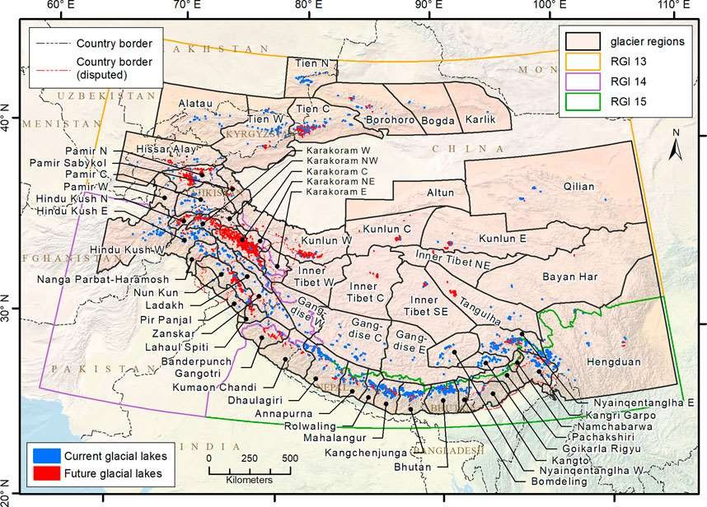
Figure. 1. Glacial lake layout [1] for High Mountain Asia region
- Dataset Description
The dataset used as a case study, comprises 1200 images and their corresponding ground truth masks, covering the area of 2080.12 km².This dataset was accessed from IEEE Dataport after purchasing its membership.
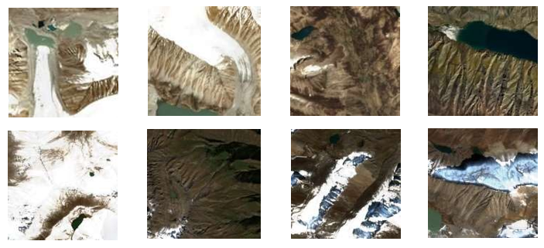
Figure. 2. Random images from the Sentinel-2 dataset displaying lakes of different colors and varying topographical features, including snow-covered mountains and glacial terrain.

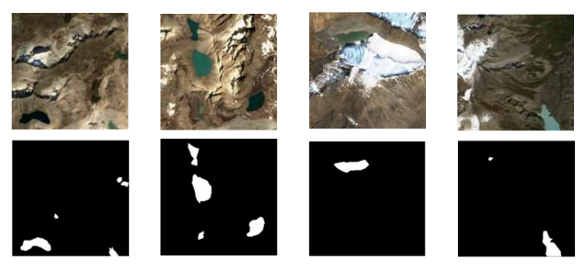

Figure. 3. Row 1 shows the Sentinel-2 RGB colored images of glacial lakes, Row 2 shows their respective ground truth masks.
As per the dataset description, to create this valuable resource, cloud-free, multispectral Sentinel-2 data was acquired from the Sentinel Hub EO Browser, ultimately retaining around 400 scenes for processing. From these scenes, 1200, 320x320 pixel crops containing glacial lakes were generated, preserving the original pixel resolution. Figure 2 shows the diversity of this dataset, showcasing true- color images with varying glacial lake radiometric signatures. A binary method is used to classify each image, with 1 denoting the presence of a lake and 0 denoting its absence. The dataset is separated into two sets: one for testing, which has 200 photos, and another for training, which has 1000. Four instances from our training dataset are shown in Figure 3, along with the labels for the ground truth masks that match to the true-color images.

Methodology
Three different DL models with different loss functions and backbones have been used. With a more robust decoder module, DeepLabV3+ [2], an upgraded CNN made for image segmentation tasks, improves on the original DeepLab models and increases segmentation accuracy, especially along object boundaries. ImageNet pre-trained weights were used to pair the DeepLabV3+ model with the ResNet50 backbone. We employed a batch size of eight and supplemented the data with a variety of strategies. We employed Adam as our optimiser, which had a training rate of 0.001 and a learning rate of 1e-3. Memory use is low and performance is effective with this method. We explored different functions for calculating loss, including binary cross-entropy, binary focal, and dice loss. The second model we utilized is the U-Net Encoder-Decoder segmentation network [3], paired with both ResNet50 and EfficientNetB0 backbones, also using ImageNet pre-trained weights as ImageNet has a vast collection of images that the models were pre-trained on.
All models were trained for 30 epochs. We observed that the DeepLabV3+ model exhibits a temporary divergence during training, followed by enhanced performance compared to previous iterations. Data was preprocessed, augmented and fed in to the DL models with varying batch sizes, learning rates and other hyperparameters.
- Proposed System Model
Dataset images encompass numerous intricate features, including glaciers, vegetation, exposed ground, mountain shadows. This study exclusively focuses on glacial lake feature images, along with their corresponding masks. The DeepLab series for semantic segmentation includes DeepLabV3+ [2], which utilizes Atrous Spatial Pyramid Pooling (ASPP) to enhance multi-scale context extraction. ASPP allows for greater contextual aggregation without appreciably boosting computation by using atrous convolutions at varying rates to capture a variety of features. For context capture and spatial reconstruction, the U-Net model relies on an encoder-decoder architecture; Res-Net improves this by adding skip connections for improved gradient flow and sophisticated feature learning. In our investigation, the U-Net with a ResNet-50 backbone and pre-trained ImageNet weights successfully classified and segmented photos of glacial lakes, but it did not outperform other specialised segmentation models.
To determine the error and gap, we employed two primary loss function types for our model: dice loss and cross-entropy loss, which were employed in the DeepLabV3+ and U-Net models. In image segmentation tasks, the cross-entropy loss function evaluates alignment with target labels by calculating the difference between the model's predicted and true probability distributions.
$$L=-\sum_{i=1}^{N}{y_{i}} log⁡(\hat{y_{i}})$$
By calculating the degree of similarity between the target and predicted segmentations, Dice Loss—which is derived from the Dice Similarity Coefficient—assesses the performance of ML models in segmentation tasks.
$$L_{Dice }=1- \frac{2(y\overline{p}+1)}{(y+\overline{p}+1)}$$
- Evaluation Metrices
The IoU score has been our primary evaluation statistic, along with precision, recall, and F1-score.
Intersection over Union (IoU) measures object detection accuracy by assessing the overlap between predicted and actual bounding boxes or segmented regions.
$$IoU=\frac{|A∩B|}{|A∪B|}$$
The precision of a model is determined by dividing the number of correct positives by the total number of positive predictions; larger values signify better precision.
$$Precision= \frac{TP}{TP+FP}$$

Recall measures how well a model detects positive events by dividing the number of real positives by the total number of actual positives, which includes both false negatives and true positives.
$$Recall= \frac{TP}{TP+FN}$$

F1-score (F1) rate is the harmonic mean of precision value and recall rate:
$$F1=2∙\frac{Precision∙Recall}{Precision+Recall}$$

Two different sets, A and B, are compared to determine how similar they are using a quantitative calculation called the Dice Coefficient (DL = 1 – Dice Coeff). The value of the coefficient falls between 0 and 1.
$$D=\frac{2|A∩B|}{\left|A\right|+|B|}$$

- Evaluation metrics table
Model +  Backbone | Loss  Function | Dice  Coeff | Accuracy | Precision | Recall
DeepLabV3+ ResNet50 | Cross entropy | 0.7332 | 0.9004 | 0.9336 | 0.7126
DeepLabV3+ ResNet50 | Dice Loss | 0.8261 | 0.8188 | 0.8154 | 0.7752
U-Net + EfficientNetB0 | Cross entropy | 0.5594 | 0.9878 | 0.7205 | 0.7344
U-Net | Cross entropy | 0.8439 | 0.9860 | 0.9149 | 0.8406
U-Net + ResNet50 | Cross entropy | 0.7582 | 0.9025 | 0.8604 | 0.7635

Results And Discussion
A GradCam visualisation, a predicted segmentation mask, and the predicted mask superimposed on the original image comprise our results. GradCam generates a preliminary localisation map that identifies the areas of the image that are most important for the target concept prediction of the model. The backbone and loss function employed in the DeepLabV3+ architecture showed notable differences in performance. Using a cross-entropy loss and ResNet50 backbone, the model's IoU was 66.09%. Using Dice Loss raised the IoU to 74.69% and improved the Dice coefficient to 0.8261. These results imply that the model's performance can be significantly affected by the loss function selection, with Dice Loss producing superior outcomes. Tables I and II display the findings.
In order to balance processing efficiency and gradient flow, the U-net [3] models combined the ResNet50 and EfficientNetB0 backbones. U-Net achieved an IoU of 40.71% using an EfficientNetB0 backbone with cross-entropy loss. On the other hand, the IoU of 58.60% was lower for the U-Net with a ResNet50 backbone and cross-entropy loss. An IoU score of 73.30% was achieved by the simple U-Net without a complex backbone when cross-entropy loss was present.
The model with the highest performance across all the models and combinations evaluated was the DeepLabV3+ with a ResNet50 backbone and Dice Loss function. With an IoU score of 74.69%, this combination exhibited an exceptional capacity to accurately delineate glacier lakes within satellite imagery. The improvement in performance demonstrates how critical it is to use the appropriate architecture components and loss function to promote model efficiency. All of our models were trained using 1,000 images and their corresponding segmentation masks, with IoU as the primary metric for evaluation. Through extensive hyperparameter tuning and sustained runs on the validation set, our models delivered attractive performance.
IoU Score Calculation: The IoU scores for the models under our consideration are reported in Table II. IoU is measured as a paradigm for performance. Since it measures the degree of overlap between the ground truth versus expected bounding boxes, IoU is important for both detection and segmentation.
Higher IoU scores suggest superior model performance and better agreement with real object boundaries. Accurately defining glacial lake borders in GLOF detection requires high IoU scores, which are necessary for efficient monitoring and early warning systems.
Finding the most dependable deep learning architectures for accurate detection is made easier by comparing IoU scores across models.
With the best IoU score of 74.69%, the DeepLabV3+ model with a ResNet50 backbone and Dice Loss function proved to be the most effective in precisely estimating the spatial extent of glacial lakes. This model's remarkable accuracy is probably due to the combination of its strong backbone and efficient loss function.
The same model using a cross-entropy loss function, in contrast, obtained a marginally lower IoU score of 66.09%, suggesting that, even if it is still quite successful, performance optimisation depends critically on the loss function selection.
The IoU rate values are compared with one another in Table II to determine which model yielded the best results.
- IoU scores table
Model | Backbone | Loss function | IoU%
DeepLabV3+ | ResNet50 | Cross entropy | 66.09%
DeepLabV3+ | ResNet50 | Dice Loss | 74.69%
U-Net | EfficientNetB0 | Cross entropy | 40.71%
U-Net | None | Cross entropy | 73.30%
U-Net | ResNet50 | Cross entropy | 58.60%

Limitations and future research directions
Deployment and computational efficiency: Since compute and network resources are restricted, high-resolution remote sensing products are frequently too expensive to analyse in real time. Subsequent studies will concentrate on shrinking models and processes through methods such as edge-friendly pipelines, lightweight backbones, model pruning, and knowledge distillation. By doing this, segmentation quality will be preserved while inference is enabled on low-power devices and sporadic connections.
Sturdiness and mistake prevention: Both false alarms and missing detections have major repercussions in areas that are vulnerable to GLOF. In order to minimise false alarms and enhance decision dependability, future studies will combine calibrated uncertainty measurements and thresholding techniques with a focus on thorough, stress-tested validation spanning seasons, illumination, and snow/ice conditions.
Contextual inputs and multi-source fusion: In intricate mountain landscapes, single-source optical imaging may be unclear. In order to generate context-aware risk scores that are more meaningful than independent segmentation outputs, future work will create fusion frameworks that integrate satellite images with hydrological, meteorological, topographic, and in-situ sensor data.
Model and training enhancements Future research will investigate customised architectures, hybrid attention mechanisms, and unique loss functions that prioritise boundary correctness and class imbalance in order to increase segmentation fidelity for tiny, irregular lakes. Better transfer learning and repeatable comparisons will be made possible by the development and dissemination of standardised, well-annotated datasets including various glacier environments.
Operational integration and societal impact: In order to ensure that technological advancements result in timely, actionable warnings and decreased risk for vulnerable communities, research will go beyond model benchmarks and operationalise, incorporating optimised algorithms into automated monitoring systems, alert pipelines, and stakeholder-focused tools.

Conclusion
In order to address climate change issues in high-altitude regions, it is essential to identify and monitor GLOFs. Our study leverages contemporary deep learning architecture to segment glacial lakes using the DeepLabv3+ model with a ResNet50 backbone, which outperforms the other models with an IoU score of 74.69% and 90% accuracy along with 98% with U-Net + EfficientNetB0.
The reliability of the model's results and ultimate usability are important traits of deep learning architecture in creating viable disaster management approaches. Glacial lake outburst floods (GLOFs) can cause substantial harm to infrastructure and communities in India and other regions such as the Himalayas. Having timely monitoring alerts can help mitigate the risks associated with GLOFs. This research emphasizes complex frameworks and data management for comprehensive systems design while having a potentially significant social impact.

References

- S. K. Allen et al., “Potentially dangerous glacial lakes across the Tibetan Plateau revealed using a large-scale automated assessment approach”, Sci. Bull., vol. 64, no. 7, pp. 435-445, 2019.
- Chen, L., Zhu, Y., Papandreou, G., Schroff, F., & Adam, H. (2018). Encoder-Decoder with Atrous Separable Convolution for Semantic Image Segmentation. ArXiv. /abs/1802.02611
- Sharma, Anita & Prakash, Chander & Thakur, Divyansh. (2024). Glacier Lake Detection Utilizing Remote Sensing Integration with Satellite Imagery and Advanced Deep Learning Methods. Applied Geomatics. 16. 10.1007/s12518-024-00594-3.
- J. M. Su, L. X. Yang, and W. P. Jing, “A U-net based semantic segmentation method for high resolution remote sensing image,” Comput. Eng. Appl., vol. 55, no. 7, pp. 207–213, 2019
- Zhang M, Chen F, Zhao H, Wang J, Wang N. Recent Changes of Glacial Lakes in the High Mountain Asia and Its Potential Controlling Factors Analysis. Remote Sensing. 2021; 13(18):3757. https://doi.org/10.3390/rs13183757
- Kaushik, Saurabh & Singh, Tejpal & Joshi, P.K. & Andreas, Dietz. (2022). Automated mapping of glacial lakes using multisource remote sensing data and deep convolutional neural network. International Journal of Applied Earth Observation and Geoinformation. 115. 103085. 10.1016/j.jag.2022.103085
- Hu S, Liu J, Kang Z. DeepLabV3+/EfficientNet Hybrid Network-Based Scene Area Judgment for the Mars Unmanned Vehicle System. Sensors. 2021; 21(23):8136. doi.org/10.3390/s21238136
- Cheng, Bowen & Girshick, Ross & Dollar, Piotr & Berg, Alexander & Kirillov, Alexander. (2021). Boundary IoU: Improving Object-Centric Image Segmentation Evaluation. 15329-15337. 10.1109/CVPR46437.2021.01508.
- Mingxing Tan and Quoc Le. Efficientnet: Rethinking model scaling for convolutional neural networks. In International conference on machine learning, pages 6105–6114. PMLR, 2019.
- Agrawal, Sanjay & Rewaskar, Vaibhav & Agrawal, Rucha & Chaudhari, Swapnil & Patil, Yogendra & Agrawal, Nidhee. (2023). International Journal of INTELLIGENT SYSTEMS AND APPLICATIONS IN ENGINEERING Advancements in NSFW Content Detection: A Comprehensive Review of ResNet-50 Based Approaches. 11. 41-45.
- Z. Duan, F. Wang, B. Wang, G. Luo and Z. Jiang, "An Adapted ResNet-50 Architecture for Predicting Flow Fields of an Underwater Vehicle," in IEEE Access, vol. 12, pp. 66398-66407, 2024, doi: 10.1109/ACCESS.2024.3399077.
- J. Zhang, X. Yao, H. Duan, X. Chu, C. Yang and J. Hu, "Extraction of Cladophora Blooms in Qinghai Lake Through the Integration of Sentinel-2 MSI Imagery and Deep Learning Techniques," in IEEE Journal of Selected Topics in Applied Earth Observations and Remote Sensing, vol. 17, pp. 19115-19129, 2024, doi: 10.1109/JSTARS.2024.3447886.
- Z. Zhan, X. Zhang, Y. Liu, X. Sun, C. Pang and C. Zhao, "Vegetation Land Use/Land Cover Extraction From High-Resolution Satellite Images Based on Adaptive Context Inference," in IEEE Access, vol. 8, pp. 21036-21051, 2020, doi: 10.1109/ACCESS.2020.2969812.
- K. Thitisiriwech, T. Panboonyuen, P. Kantavat, Y. Iwahori and B. Kijsirikul, "The Bangkok Urbanscapes Dataset for Semantic Urban Scene Understanding Using Enhanced Encoder-Decoder with Atrous Depthwise Separable A1 Convolutional Neural Networks," in IEEE Access, vol. 10, pp. 59327-59349, 2022, doi: 10.1109/ACCESS.2022.3176712.
- F. Chen, M. Zhang, B. Tian and Z. Li, "Extraction of Glacial Lake Outlines in Tibet Plateau Using Landsat 8 Imagery and Google Earth Engine," in IEEE Journal of Selected Topics in Applied Earth Observations and Remote Sensing, vol. 10, no. 9, pp. 4002-4009, Sept. 2017, doi: 10.1109/JSTARS.2017.2705718.
- A. Ortiz et al., "Mapping Glacial Lakes Using Historically Guided Segmentation Models," in IEEE Journal of Selected Topics in Applied Earth Observations and Remote Sensing, vol. 15, pp. 9226-9240, 2022, doi: 10.1109/JSTARS.2022.3215722.
- J. -H. Lee et al., "Detection and Dispersion of Small-Scale Oil Spills in Pristine Coastal Waters Using Sentinel-2 Satellite Imagery: A Case Study From Jeju Island," in IEEE Journal of Selected Topics in Applied Earth Observations and Remote Sensing, vol. 18, pp. 24848-24863, 2025, doi: 10.1109/JSTARS.2025.3613018.
- Z. Li, B. Ouyang, S. Qiu, X. Xu, X. Cui and X. Hua, "Change Detection in Remote-Sensing Images Using Pyramid Pooling Dynamic Sparse Attention Network with Difference Enhancement," in IEEE Journal of Selected Topics in Applied Earth Observations and Remote Sensing, vol. 17, pp. 7052-7067, 2024, doi: 10.1109/JSTARS.2024.3374050.
- Raj, S., Tripathi, S., Tripathi, K.C. et al. Hybrid optimized deep recurrent neural network for atmospheric and oceanic parameters prediction by feature fusion and data augmentation model. J Comb Optim 47, 66 (2024). https://doi.org/10.1007/s10878-024-01159-1

